# Assignment Week 9

Visualize data using Gephi – Linfang Yang

1. Visualize comic / hero dataset

This ranks the nodes using page rank algorithm, as shown, Caption American shows up highest and followed by some comic books and other famous super hero. This also used the rotate plugin to pick the best angle for screenshot

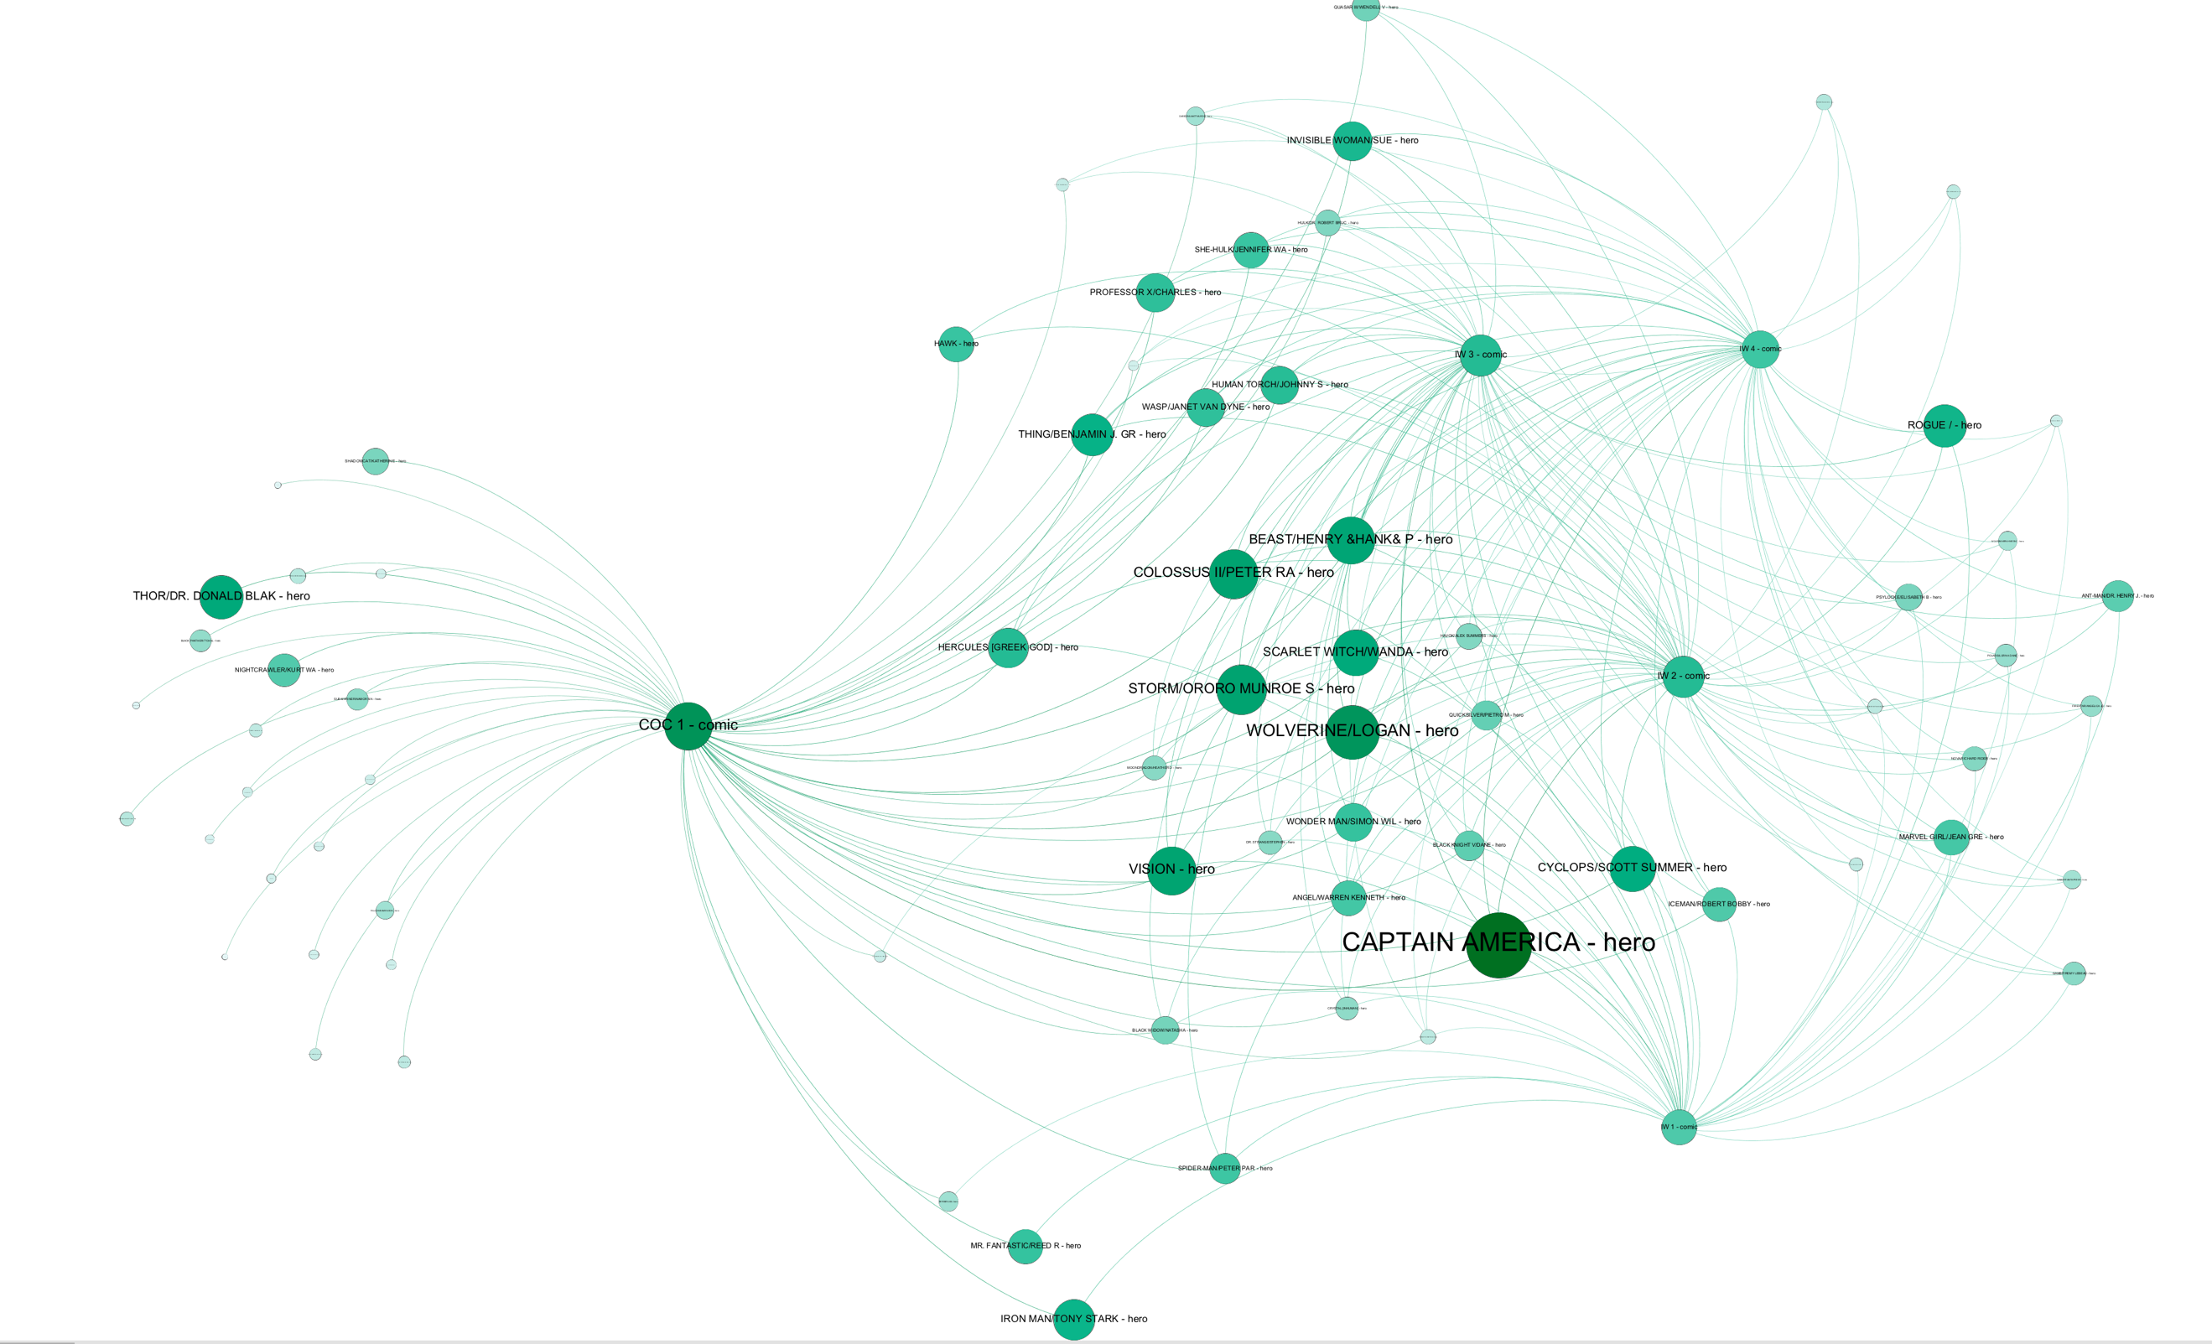

1. Visualize coauthor dataset

This shows Newman M as the top author that co-authors with other researchers, also showed several connected groups who tend to co-author with each other.

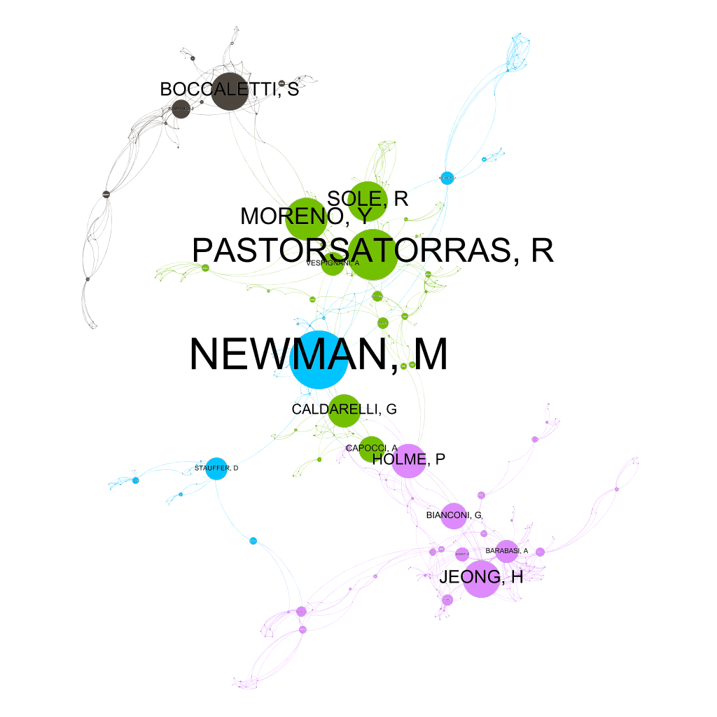

1. Visualize jazz dataset

This visualizes jazz dataset using partition by modularity class. And ranked using degree. As shown number 136 has the highest degree. This dataset only has number label so hard to make sense out of dataset compared to previous ones.

